Roll No. : 18WH1A1252 Date:

**Aim:** Install TOMCAT web server. Convert the static web pages of assignments 2 into dynamic web pages using servlets and cookies. Hint: Users information (user id, password, credit card number) would be stored in web.xml. Each user should have a separate Shopping Cart.

**Program:**

**Main.html**

<!DOCTYPEhtml>

<html>

<head>

<metacharset=*"UTF-8"*>

<title>Main Shopping Cart Page</title>

</head>

<bodybgcolor=*"yellow"*>

<br/><br/><br/><br/><br/>

<h1style="color:*red*;"align=*"center"*><U> ONLINE BOOK STORAGE </U></h1><br/><br/><br/>

<h2align=*"center"*>

<pre>

<b>Welcome to online book storage. <br><br>

Press LOGIN if you are having id otherwise press REGISTRATION

</b>

</pre>

</h2>

<br/><br/>

<pre>

<divalign=*"center"*>

<astyle="color:*red*; font size:*15px*;"href=*"LoginPage.html"*>LOGIN</a>

<astyle="color:*red*; font-size:*15px*;"href=*"RegistrationPage.html"*> REGISTRATION</a></div>

</pre>

</body>

</html>

**Registration.html**

<!DOCTYPEhtml>

<html>

<head>

Roll No. : 18WH1A1252 Date:

<metacharset=*"UTF-8"*>

<title>Shopping Cart Registration Page</title>

</head>

<bodybgcolor=*"#FFC"*>

<formname=*"myform""*>

<h1style="margin-top: *60px*;"align=*"center"*> Registration </h1> method=*"post"*action=*"Registration1*

<tablealign=*"center"*>

<tr>

<td></td>

<td><inputstyle="margin-top: *70px*; font-size: *18pt*; height: *40px*; width:*280px*;"placeholder=*"NAME"*type=*"text"*name=*"name"*/></td>

</tr>

<tr>

<td></td>

<td><inputstyle="font-size: *18pt*; height: *40px*; width:*280px*;"placeholder=*"ADDRESS"*type=*"text"*name=*"addr"*/></td>

</tr>

<tr>

<td></td>

<td><inputstyle="font-size: *18pt*; height: *40px*; width:*280px*;"placeholder=*"CONTACT NUMBER"*type=*"text"*name=*"phno"*/></td>

</tr>

<tr>

<td></td>

<td><inputstyle="font-size: *18pt*; height: *40px*; width:*280px*;"placeholder=*"LOGIN ID"*type=*"text"*name=*"id"*/></td>

</tr>

<tr>

<td></td>

<td><inputstyle="font-size: *18pt*; height: *40px*; width:*280px*;"placeholder=*"PASSWORD"*type=*"password"*name=*"pswd"*/></td>

</tr>

Roll No. : 18WH1A1252 Date:

</table>

<br/><br/><divalign=*"center"*>

<inputstyle="font-size: *18pt*;height: *40px*; width:*80px*;"type=*"submit"*value=*"ok"*onclick="validate()"/>&nbsp;&nbsp;&nbsp;&nbsp;&nbsp;&nbsp;<inputstyle="font-size: *18pt*;height: *40px*; width:*80px*;"type=*"reset"*value=*"clear"*/>

</div>

</form>

</body>

</html>

**Login.html**

<DOCTYPEhtml>

<html>

<meta charset=*"UTF-8"*>

<title>Login Page</title

</head>

<body bgcolor=*"pink"*>

<form name=*"myform"* method=*"post"* action=*"login"*>

<h1 style="margin-top: *30px*;" align=*"center"*>Welcome to Login Page</h1>

<div align=*"center"*><pre>

<input style="margin-top: *150px*; font-size: *18pt*; height: *40px*; width:*280px*;" placeholder=*"LOGIN ID"* type=*"text"* name=*"id"* /><br />

<input style="font-size: *18pt*; height: *40px*; width:*280px*;" placeholder=*"password"* type=*"password"* name=*"pswd"* /></pre><br /><br />

</div>

<br /><br />

<div align=*"center"*>

<input style="font-size: *18pt*;height: *40px*; width:*80px*;"type=*"submit"* value=*"ok"* onclick="validate()" />&nbsp;&nbsp;&nbsp;&nbsp;&nbsp;&nbsp;

<input style="font-size: *18pt*;height: *40px*; width:*80px*;" type=*"reset"* value=*"clear"* />

</div>

</form>

</body>

</html>

Roll No. : 18WH1A1252 Date:

**Order.html**

<!DOCTYPE html>

<html>

<head>

<meta charset=*"UTF-8"*>

<title>User Order Page</title>

</head>

<body bgcolor=*"#4dffff"*>

<br /><br />

<h1 style="margin-top: *60px*;" align = *"center"*>Please Place your Order</h1>

<form method=*"post"* action=*"Order"*>

<div align=*"center"*>

<table align=*"center"*>

<tr><td></td><td><input style="margin-top: *70px*; font-size: *18pt*; height: *40px*; width:*280px*;" placeholder=*"LOGIN ID"* type=*"text"* name=*"id"* /></td></tr>

<tr><td></td><td><input style="font-size: *18pt*; height: *40px*; width:*280px*;" placeholder=*"PASSWORD"* type=*"password"* name=*"pswd"* /></td></tr>

<tr><td></td><td><input style="font-size: *18pt*; height: *40px*; width:*280px*;" placeholder=*"TITLE"* type=*"text"* name=*"title"* /></td>

<tr><td></td><td><input style="font-size: *18pt*; height: *40px*; width:*280px*;" placeholder=*"NO OF BOOKS"* type=*"text"* name=*"no"* /></td></tr>

<tr><td></td><td><input style="font-size: *18pt*; height: *40px*; width:*280px*;" placeholder=*"DATE"* type=*"text"* name=*"date"* /></td></tr>

<tr><td></td><td><input style="font-size: *18pt*; height: *40px*; width:*280px*;" placeholder=*"CREDIT CARD NUMBER"* type=*"password"* name=*"cno"* /></td></tr>

</table>

</div>

<br /><br />

<div align=*"center"*>

<input style="font-size: *18pt*;height: *40px*; width:*80px*;" type=*"submit"* value=*"ok"* name=*"button1"*/>&nbsp;&nbsp;&nbsp;&nbsp;&nbsp;&nbsp;<input style="font-size: *18pt*;height: *40px*; width:*80px*;" type=*"reset"* value=*"clear"* name=*"button2"*/>

Roll No. : 18WH1A1252 Date:

</div>

</form>

</body>

</html>

**Profile.html**

<!DOCTYPE html>

<html>

<head>

<meta charset=*"UTF-8"*>

<title>User Profile Page</title>

</head>

<body bgcolor=*"yellow"*>

<form name=*"myform"* method=*"post"* action=*"Profile"*>

<div align=*"center"*><pre>

<input style="margin-top: *150px*; font-size: *18pt*; height: *40px*; width:*280px*;" placeholder=*"LOGIN ID"* type=*"text"* name=*"id"* /><br />

</pre><br /><br />

</div>

<br /><br />

<div align=*"center"*>

<input style="font-size: *18pt*;height: *40px*; width:*80px*;" type=*"submit"* value=*"ok"* onclick="validate()" />&nbsp;&nbsp;&nbsp;&nbsp;&nbsp;&nbsp;

<input style="font-size: *18pt*;height: *40px*; width:*80px*;" type=*"reset"* value=*"clear"* />

</div>

</form>

</body>

</html>

**Catalog.html**

<!DOCTYPE html>

<html>

Roll No. : 18WH1A1252 Date:

<head>

<meta charset=*"UTF-8"*>

<title>Catalog Page</title>

</head>

<body bgcolor = *"#ffcc66"*>

<br /><br /><br />

<form method=*"post"* action=*"Catalog"*>

<div align=*"center"*><pre>

<input style="margin-top: *150px*; font-size: *18pt*; height: *40px*; width:*280px*;" placeholder=*"BOOK TITLE"* type=*"text"* name=*"title"* /><br />

</pre><br /><br />

</div>

<br /><br />

<div align=*"center"*>

<input style="font-size: *18pt*;height: *40px*; width:*80px*;" type=*"submit"* value=*"ok"* name=*"button1"*/>&nbsp;&nbsp;&nbsp;&nbsp;&nbsp;&nbsp;

<input style="font-size: *18pt*;height: *40px*; width:*80px*;" type=*"reset"* value=*"clear"* name=*"button2"*/>

</div>

</form>

</body>

</html>

**Registration1.java**

package com.servlet;

import java.io.IOException;

import java.io.PrintWriter;

import java.sql.Connection;

import java.sql.DriverManager;

import java.sql.ResultSet;

import java.sql.SQLException;

import java.sql.Statement;

import javax.servlet.ServletException;

Roll No. : 18WH1A1252 Date:

import javax.servlet.annotation.WebServlet;

import javax.servlet.http.HttpServlet;

import javax.servlet.http.HttpServletRequest;

import javax.servlet.http.HttpServletResponse;

@WebServlet("/Registration1")

public class Registration1 extends HttpServlet {

private static final long serialVersionUID = 1L;

protected void doPost(HttpServletRequest request, HttpServletResponse response) throws ServletException, IOException {

PrintWriter out = response.getWriter();

out.println("<html><body>");

String name = request.getParameter("name");

String address = request.getParameter("addr");

String phno = request.getParameter("phno");

String id = request.getParameter("id");

String pswd1 = request.getParameter("pswd");

try {

Class.forName("com.mysql.jdbc.Driver");

try {

Connection con = (Connection) DriverManager.getConnection("jdbc:mysql://localhost:3306/shoppingcart", "root", "divya");

System.out.println("Connection Established");

Statement stmt = con.createStatement();

//out.println("Connected");

ResultSetrs = stmt.executeQuery("select * from RegistrationDetails");

int flag = 0;

while(rs.next())

Roll No. : 18WH1A1252 Date:

{

if(id.equals(rs.getString("id"))&&pswd1.equals(rs.getString("pswd")))

{

flag += 1;

}

}

if(flag == 1)

{

out.println("ALREADY EXITS TRY AGAIN WITH NEW ID<br><br>");

out.println("<a href=\"registrationPage.html\">press REGISTER to RETRY</a>");

}

else

{

Statement stmt1=con.createStatement();

//out.println("Connected");

stmt1.executeUpdate("insert into RegistrationDetails values('"+name+"','"+address+"','"+phno+"','"+id+"','"+pswd1+"')");

out.println("<br><br><h2>YOUR DETAILS ARE ENTERED <h2><br><br> ");

}

} catch (SQLException e) {

// TODO Auto-generated catch block

e.printStackTrace();

}

} catch (ClassNotFoundException e) {

// TODO Auto-generated catch block

e.printStackTrace();

}

out.println("<a href=\"LoginPage.html\"> LOGIN </a>");

out.println("</body></html>");

}

}

Roll No. : 18WH1A1252 Date:

**Login.java**

package com.servlet;

import java.io.IOException;

import java.io.PrintWriter;

import java.sql.Connection;

import java.sql.DriverManager;

import java.sql.ResultSet;

import java.sql.SQLException;

import java.sql.Statement;

import javax.servlet.ServletException;

import javax.servlet.annotation.WebServlet;

import javax.servlet.http.HttpServlet;

import javax.servlet.http.HttpServletRequest;

import javax.servlet.http.HttpServletResponse;

/**

* Servlet implementation class login

*/

@WebServlet("/login")

public class login extends HttpServlet {

private static final long serialVersionUID = 1L;

public login() {

super();

// TODO Auto-generated constructor stub

}

protected void doPost(HttpServletRequest request, HttpServletResponse response) throws ServletException, IOException {

PrintWriter out = response.getWriter();

out.println("<html><body>");

String id = request.getParameter("id");

String pswd = request.getParameter("pswd");

try {

Roll No. : 18WH1A1252 Date:

Class.forName("com.mysql.jdbc.Driver");

try {

Connection con = (Connection) DriverManager.getConnection("jdbc:mysql://localhost:3306/shoppingcart", "root", "divya");

Statement stmt = con.createStatement();

ResultSetrs = stmt.executeQuery("select * from RegistrationDetails");

int flag = 0;

while(rs.next())

{

if(id.equals(rs.getString("id")) &&pswd.equals(rs.getString("pswd")))

{

flag += 1;

}

}

if(flag == 0)

{

out.println("<br><br> SORRY INVALID ID OR PASSWORD <br><br>");

out.println("<a href=\"loginPage.html\">press LOGIN to RETRY</a>");

}

else

{

out.println("Welcome" + " " + id);

out.println("<br><br>VALID LOGIN ID<br><br>");

out.println("<h3><ul>");

out.println("<li><a href=\"Profile.html\"><fontcolor=\"black\"> USER PROFILE </font></a></li><br><br>");

out.println("<li><a href=\"CatalogPage.html\"><fontcolor=\"black\"> BOOKS CATALOG</font></a></li><br><br>");

out.println("<li><a href=\"OrderPage.html\"><fontcolor=\"black\"> ORDER CONFIRMATION</font></a></li></ul><br><br>");

}

out.println("</body></html>");

Roll No. : 18WH1A1252 Date:

} catch (SQLException e) {

// TODO Auto-generated catch block

e.printStackTrace();

}

} catch (ClassNotFoundException e) {

// TODO Auto-generated catch block

e.printStackTrace();

}

}

}

**Profile.java**

package com.servlet;

import java.io.IOException;

import java.io.PrintWriter;

import java.sql.Connection;

import java.sql.DriverManager;

import java.sql.ResultSet;

import java.sql.SQLException;

import java.sql.Statement;

import javax.servlet.ServletException;

import javax.servlet.annotation.WebServlet;

import javax.servlet.http.HttpServlet;

import javax.servlet.http.HttpServletRequest;

import javax.servlet.http.HttpServletResponse;

@WebServlet("/Profile")

public class Profile extends HttpServlet {

private static final long serialVersionUID = 1L;

Roll No. : 18WH1A1252 Date:

protected void doPost(HttpServletRequest request, HttpServletResponse response) throws ServletException, IOException {

PrintWriter out = response.getWriter();

out.println("<html><body>");

String id = request.getParameter("id");

try {

Class.forName("com.mysql.jdbc.Driver");

try {

Connection con = (Connection) DriverManager.getConnection("jdbc:mysql://localhost:3306/shoppingcart", "root", "divya");

Statement stmt = con.createStatement();

//out.println("Connected");

ResultSetrs=stmt.executeQuery("select * from RegistrationDetails where id = '" + id + "'");

int flag=0;

out.println("<br><br><br>");

while(rs.next())

{

out.println("<div align=\"left\">");

out.println("NAME :" + rs.getString("name") + "<br>");

out.println("ADDRESS :" + rs.getString("addr") + "<br>");

out.println("PHONE NO :" + rs.getString("phno") + "<br>");

out.println("</div>");

flag = 1;

}

if(flag==0)

{

out.println("<br><br>SORRY INVALID ID TRY AGAIN ID<br><br>");

Roll No. : 18WH1A1252 Date: 16.01.2020

out.println("<a href=\"ProfilePage.html\">press HERE to RETRY</a>");

}

} catch (SQLException e) {

// TODO Auto-generated catch block

e.printStackTrace();

}

} catch (ClassNotFoundException e) {

// TODO Auto-generated catch block

e.printStackTrace();

}

out.println("</body></html>");

}

}

**Order.java**

package com.servlet;

import java.io.IOException;

import java.io.PrintWriter;

import java.sql.Connection;

import java.sql.DriverManager;

import java.sql.ResultSet;

import java.sql.SQLException;

import java.sql.Statement;

import javax.servlet.ServletException;

import javax.servlet.annotation.WebServlet;

import javax.servlet.http.HttpServlet;

import javax.servlet.http.HttpServletRequest;

import javax.servlet.http.HttpServletResponse;

@WebServlet("/Order")

Roll No. : 18WH1A1252 Date:

public class Order extends HttpServlet {

private static final long serialVersionUID = 1L;

protected void doPost(HttpServletRequest request, HttpServletResponse response) throws ServletException, IOException {

PrintWriter out = response.getWriter();

out.println("<html><body>");

int count, amount = 0;

String id = request.getParameter("id");

String pswd1 = request.getParameter("pswd");

String title = request.getParameter("title");

String noofbooks = request.getParameter("no");

String date = request.getParameter("date");

String cno = request.getParameter("cno");

try {

count = Integer.parseInt(noofbooks);

Class.forName("com.mysql.jdbc.Driver");

try {

Connection con = (Connection) DriverManager.getConnection("jdbc:mysql://localhost:3306/shoppingcart", "root", "divya");

Statement stmt = con.createStatement();

//out.println("connected");

ResultSetrs = stmt.executeQuery("select * from RegistrationDetails");

int flag = 0;

while(rs.next())

{

if(id.equals(rs.getString("id")) && pswd1.equals(rs.getString("pswd")))

{

Roll No. : 18WH1A1252 Date:

flag += 1;

}

}

if(flag == 0)

{

out.println("<br><br> SORRY INVALID ID <br><br>");

out.println("<a href=\"loginPage.html\">press LOGIN to RETRY</a>");

}

else

{

Statement stmt1 = con.createStatement();

//out.println("connected1");

ResultSet rs1=stmt.executeQuery("select cost from Books where title = '" + title + "'");

int flag1 = 0, costofbook;

while(rs1.next())

{

costofbook = Integer.parseInt(rs1.getString("cost"));

amount += count * costofbook;

flag1 = 1;

}

if(flag1 == 1)

{

out.println("<br><br>AMOUNT:"+ amount +"<br><br><br><br>");

Statement stmt2 = con.createStatement();

//out.println("connected2");

stmt2.executeUpdate("insert into OrderDetails values ('"+ id + "','"+ pswd1 + "','" + title + "','" + noofbooks + "', '"+ date + "','" + cno + "') " );

out.println("<br><br><h2>YOUR ORDER has taken</h2><br><br>");

Roll No. : 18WH1A1252 Date:

}

else

{

out.println("<br><br><br>SORRY INVALID ID TRY AGAIN ID <br><br> ");

out.println("<a href=\"OrderPage.html\">press Order to RETRY</a>");

}

}

} catch (SQLException e) {

// TODO Auto-generated catch block

e.printStackTrace();

}

} catch (ClassNotFoundException e) {

// TODO Auto-generated catch block

e.printStackTrace();

}

out.println("</body></html>");

}

}

**Catalog.java**

package com.servlet;

import java.io.IOException;

import java.io.PrintWriter;

import java.sql.Connection;

import java.sql.DriverManager;

import java.sql.ResultSet;

Roll No. : 18WH1A1252 Date:

import java.sql.SQLException;

import java.sql.Statement;

import javax.servlet.ServletException;

import javax.servlet.annotation.WebServlet;

import javax.servlet.http.HttpServlet;

import javax.servlet.http.HttpServletRequest;

import javax.servlet.http.HttpServletResponse;

@WebServlet("/Catalog")

public class Catalog extends HttpServlet {

private static final long serialVersionUID = 1L;

protected void doPost(HttpServletRequest request, HttpServletResponse response) throws ServletException, IOException {

PrintWriter out = response.getWriter();

out.println("<html><body>");

String title = request.getParameter("title");

out.println(title);

try {

Class.forName("com.mysql.jdbc.Driver");

try {

Connection con = (Connection) DriverManager.getConnection("jdbc:mysql://localhost:3306/shoppingcart", "root", "divya");

Statement stmt = con.createStatement();

//out.println("Connected");

ResultSetrs=stmt.executeQuery("select * from Books where title = '" + title + "'");

int flag=0;

out.println("<br><br><br>");

while(rs.next())

{

out.println("<div align=\"left\">");

out.println("TITLE :" + rs.getString("title") + "<br>");

Roll No. : 18WH1A1252 Date:

out.println("AUTHOR :" + rs.getString("author") + "<br>");

out.println("VERSION :" + rs.getString("version") + "<br>");

out.println("PUBLISHER :" + rs.getString("publisher") "<br>");

out.println("COST :" + rs.getString("cost") + "<br>");

out.println("</div>");

flag = 1;

}

if(flag==0)

{

out.println("<br><br>SORRY INVALID TITLE TRY AGAIN ID<br><br>");

out.println("<a href=\"CatalogPage.html\">press HERE to RETRY</a>");

}

} catch (SQLException e) {

// TODO Auto-generated catch block

e.printStackTrace();

}

} catch (ClassNotFoundException e) {

// TODO Auto-generated catch block

e.printStackTrace();

}

out.println("</body></html>");

}

}

Roll No. : 18WH1A1252 Date:

**Web.xml**

<?xml version="1.0" encoding="UTF-8"?>

<element>

<web-app xmlns:xsi="http://www.w3.org/2001/XMLSchema-instance" xmlns="http://java.sun.com/xml/ns/javaee" xsi:schemaLocation="http://java.sun.com/xml/ns/javaee http://java.sun.com/xml/ns/javaee/web-app_3_0.xsd" id="WebApp_ID" version="3.0">

<display-name>ECommerce</display-name>

<servlet>

<servlet-name>loginservlet</servlet-name>

<servlet-class>login</servlet-class>

</servlet>

<servlet-mapping>

<servlet-name>loginservlet</servlet-name>

<url-pattern>/login</url-pattern>

</servlet-mapping>

<servlet>

<servlet-name>Registration1</servlet-name>

<servlet-class>Registration1</servlet-class>

</servlet>

<servlet-mapping>

<servlet-name>Registration1</servlet-name>

<url-pattern>/Registration1</url-pattern>

</servlet-mapping>

<servlet>

<servlet-name>Profile1</servlet-name>

<servlet-class>Profile</servlet-class>

</servlet>

<servlet-mapping>

<servlet-name>Profile1</servlet-name>

<url-pattern>/Profile</url-pattern>

</servlet-mapping>

Roll No. : 18WH1A1252 Date:

<servlet>

<servlet-name>Order1</servlet-name>

<servlet-class>Order</servlet-class>

</servlet>

<servlet-mapping>

<servlet-name>Order1</servlet-name>

<url-pattern>/Order</url-pattern>

</servlet-mapping>

</web-app>

</element>

**Outputs:**

**Main.html**

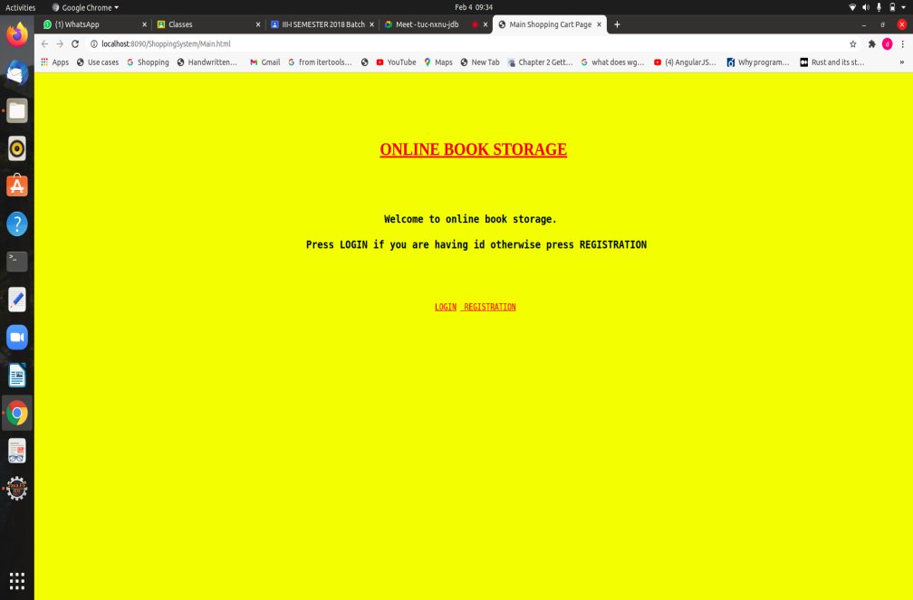

Roll No. : 18WH1A1252 Date:

**Registration.html**

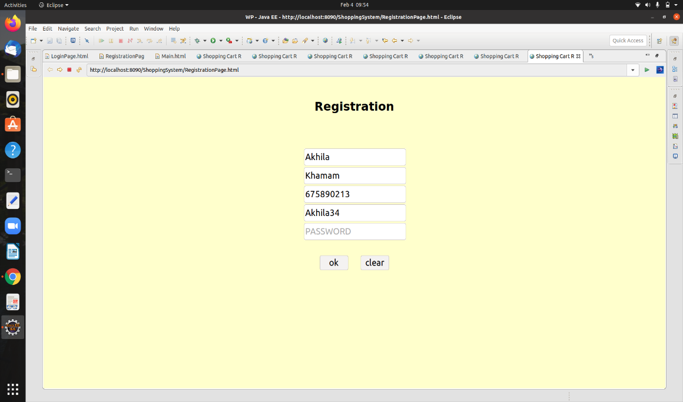

**Login.html**

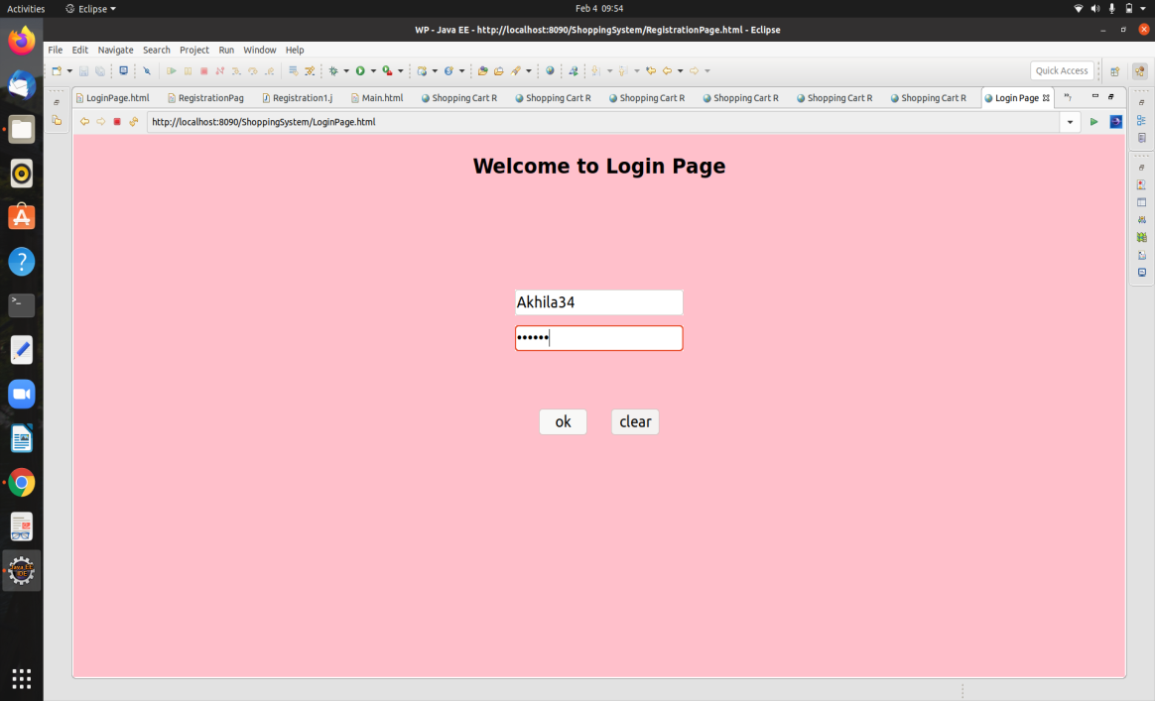

Roll No. : 18WH1A1252 Date:

**Profile.html**

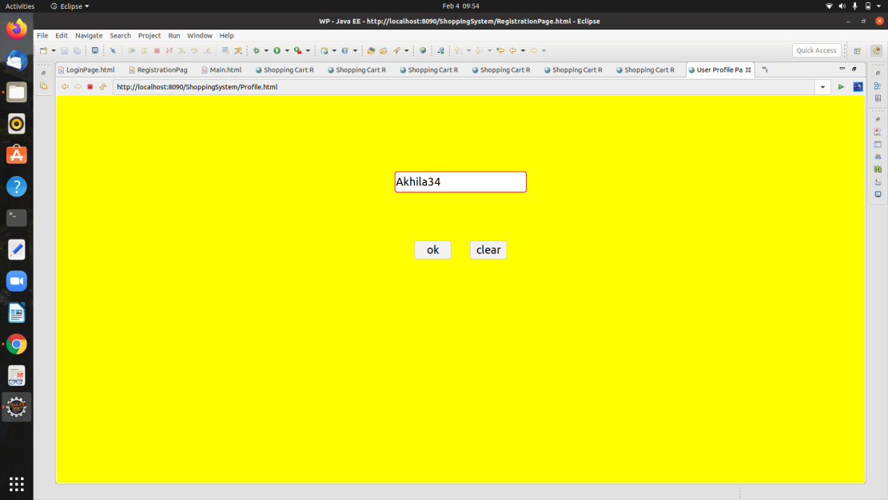

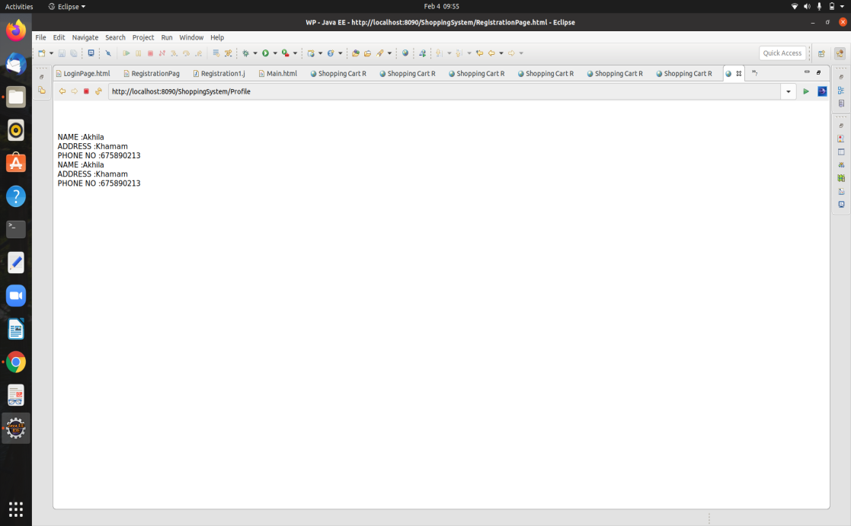

Roll No. : 18WH1A1252 Date:

**CatalogPage.html**

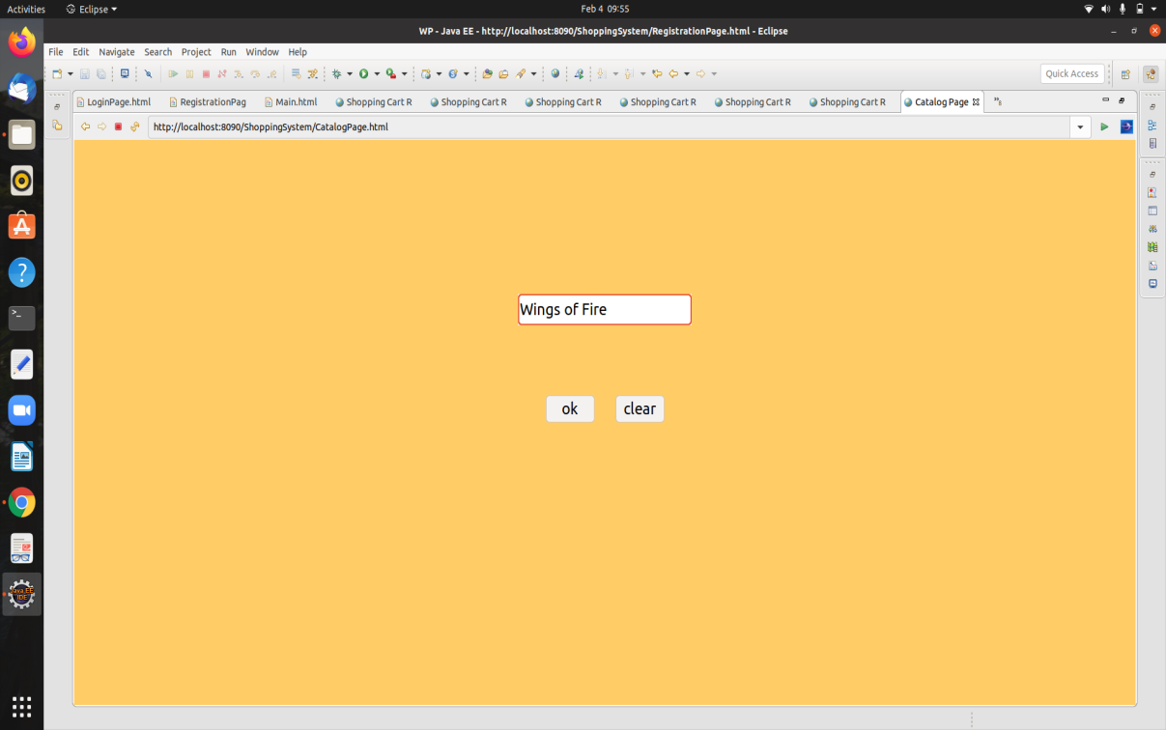

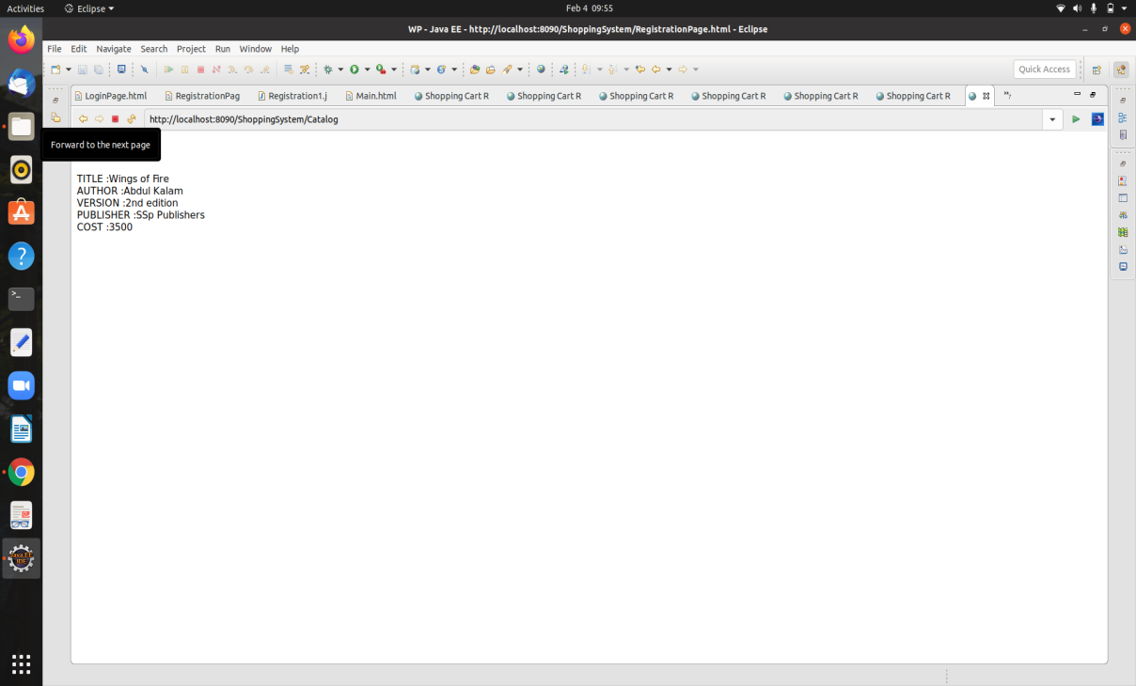

Roll No. : 18WH1A1252 Date:

**Order.html**

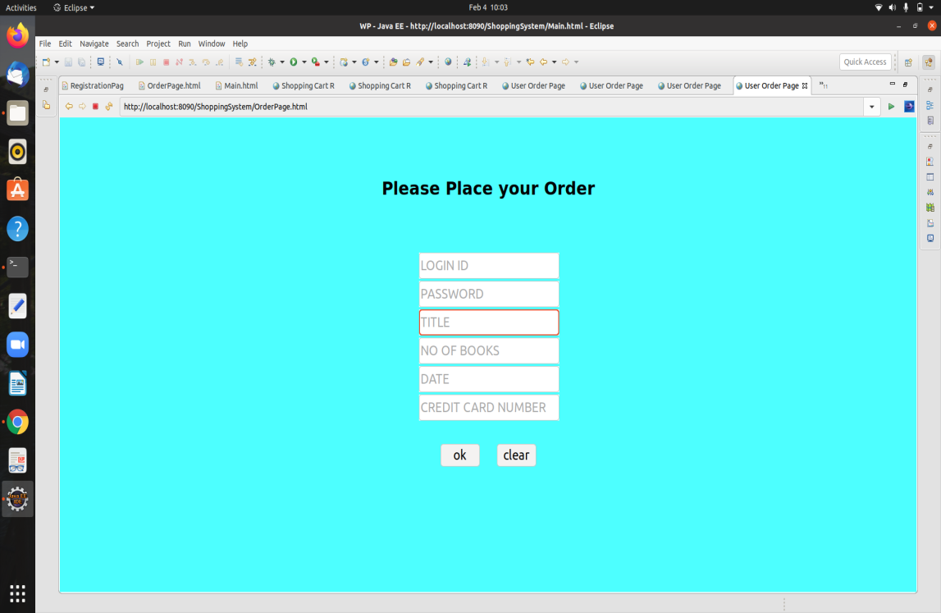

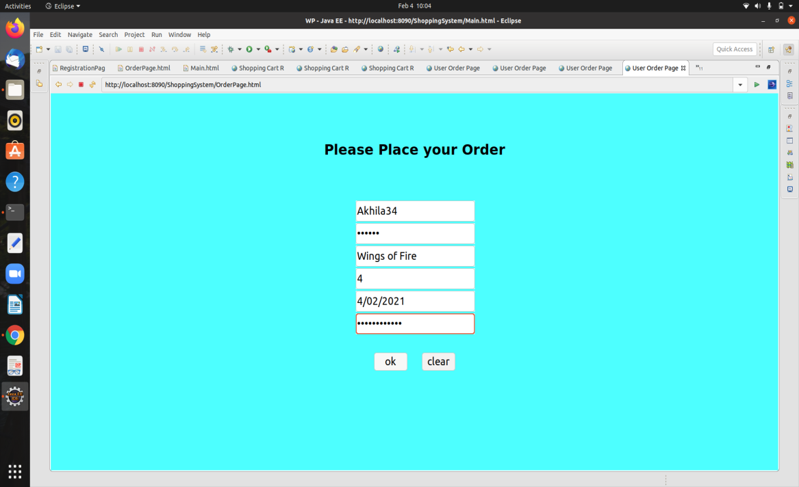

Roll No. : 18WH1A1252 Date:

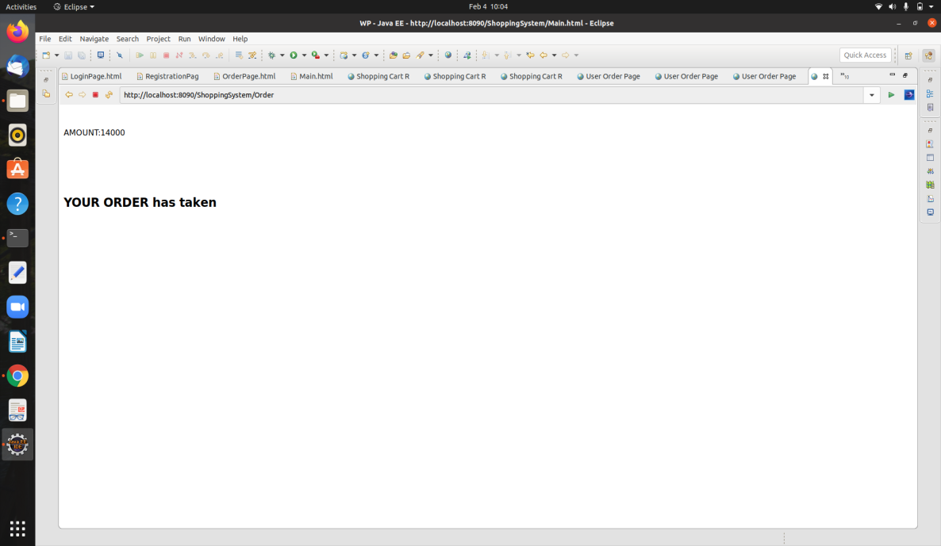

Roll No. : 18WH1A1252 Date:

**AIM**: Develop static pages (using Only HTML) of an online book store. The pages should resemble: www.amazon.com. The website should consists the following pages.

a) Home page

b) Registration and user Login

c) User Profile Page

d) Books catalog

e) Shopping Cart

f) Payment By credit card

g) Order Conformation

**Program:**

a) Home page

Main.html

<html>

<head>

<style>

.container {

position: relative;

}

.topleft {

position: absolute;

top: 8px;

left: 16px;

font-size: 18px;

}

img {

width: 100%;

height: 450px;

opacity: 1;

}

Roll No. : 18WH1A1252 Date:

</style>

</head>

<body bgcolor="cyan">

<!DOCTYPE html>

<center>

<strong>

<h1>Welcome to AMAZON</h1>

</strong>

<form method="post" action="login.html" target=_blank>

<h4>for books</h4><input type="submit" value="click here">

</form>

</center>

<div class="container">

<img src="images/book.jpg" alt="Cinque Terre" width="1000" height="50">

<div class="topleft">

</div>

</div>

</body>

</html>

b) Login &Registration page

Login page

<html>

<head>

<title>

login</title>

</head>

Roll No. : 18WH1A1252 Date:

<body bgcolor="cyan">

<center>

<strong>

<h1> AMAZON LOGIN</h1>

</strong></center>

<right>

<table align="center">

<tr>

<td>

<h4>user name

</td>

<td><input type="text"></td>

<td></td>

</tr>

<tr>

<td>

<h4>password

</td>

<td><input type="password"></td>

<td></td>

</tr>

<tr>

<td>

<form method="post" action="catalog.html">

<input type="submit" value="submit">

</form>

</td>

<td>

<form method="post" action="reg.html">

<input type="submit" value="register">

</form>

</td>

</tr>

</table>

</body>

</html>

Roll No. : 18WH1A1252 Date:

Registration page

<html>

<head>

<title>

login page</title>

</head>

<body bgcolor="cyan">

<center><strong>

<h1> AMAZON REGISTER</h1>

</strong></center>

<form method="post" action="catalog.html">

<right>

<table align="center">

<tr>

<td>

<h4>User name

</td>

<td><input type="text"></td>

<tr>

<tr>

<td>

<h4>Password

</td>

<td><input type="password"></td>

</tr>

<tr>

<td>

<h4>Confirm password

</td>

<td><input type="password"></td>

</tr>

<td>

<p>Please select your gender:</p>

</td>

<td>

<input type="radio" id="male" name="gender" value="male">

<label for="male">Male</label><br>

<input type="radio" id="female" name="gender" value="female">

Roll No. : 18WH1A1252 Date:

<label for="female">Female</label><br>

<input type="radio" id="other" name="gender" value="other">

<label for="other">Other</label>

Roll No. : 18WH1A1201 Date: 16.01.2020

</td>

<tr>

<td>Address</td>

<td><textarea name="address" rows=5 cols=19>

</textarea>

</td>

<tr>

<td>

<input type="submit" value="submit"></td>

<td>

<input type="reset" value="reset"></td>

</tr>

</form>

</body>

</html>

c) User Profile Page

<html>

<head>

<title>

userprofile</title>

</head>

<body bgcolor="cyan">

<center>

<strong>

<h1>Welcome to AMAZON Online Book Store </h1>

</strong></center>

Edit your profile here...

<form method="post" action="catalog.html">

<right>

<table align="left">

<tr>

Roll No. : 18WH1A1252 Date:

<td>

<h4>Edit user name

</td>

<td><input type="text"></td>

<tr>

<tr>

<td>

Roll No. : 18WH1A1201 Date: 16.01.2020

<h4>Edit password

</td>

<td><input type="password"></td>

</tr>

<tr>

<option>

<td>

<h4>male &nbsp;&nbsp;

<input type="radio" name="sex" id="male">

</td>

<td>

<h4>female &nbsp; &nbsp;

<input type="radio" name="sex" id="female">

</td>

</option>

</tr>

<tr>

<td>Edit Address</td>

<td><textarea name="address" rows=5 cols=19>

</textarea>

</td>

<tr>

<td>

<input type="submit" value="submit"></td>

</tr>

</form>

</body>

</html>

Roll No. : 18WH1A1252 Date:

d) Book Catalog

<html>

<head>

<title>

books catalog</title>

</head>

<body bgcolor="cyan">

<center>

<h1>AMAZON</h1>

</center>

Roll No. : 18WH1A1201 Date: 16.01.2020

<form method="post" action="shopping.html">

<left>

<table>

<tr>

<td><b>

<h3>frontend books</td>

<td></td>

</tr>

<tr>

<td></td>

<td>

<h4>html<br>

<img src="images/html.jpg" alt="Snow" style="height: 100px;">

</td>

<td></td><td></td><td></td><td></td>

<td></td><td></td><td></td><td></td>

<td>

<h4>Ads<br>

<img src="images/ads.jpg" alt="Snow" style="height: 100px;">

</td>

<td></td><td></td><td></td><td></td>

<td></td><td></td><td></td><td></td>

<td>

<h4>JAVA<br>

Roll No. : 18WH1A1252 Date:

<img src="images/java.jpeg" alt="Snow" style="height:100px;">

</td>

</tr>

<tr>

<td><b>

<h3>backend books</td>

<td></td>

</tr>

<tr>

<td></td>

<td>

<h4>Oracle<br>

<img src="images/oracle.jpeg" alt="Snow" style="height: 100px;">

</td>

<td></td><td></td><td></td><td></td>

Roll No. : 18WH1A1201 Date: 16.01.2020

<td></td><td></td><td></td><td></td>

<td>

<h4>Mysql<br>

<img src="images/mysql.jpeg" alt="Snow" style="height: 100px;">

</td>

<td></td><td></td><td></td><td></td>

<td></td><td></td><td></td><td></td>

<td>

<h4>SQL<br>

<img src="images/sql.jpeg" alt="Snow" style="height:100px;">

</td>

</tr>

</table>

</h4>

<center>

<b>for buy one of these books

<br>

</b><input type="submit" value="click here">

</center>

</form>

Roll No. : 18WH1A1252 Date:

</body>

</html>

e)Shopping Cart

<html>

<head>

<title>shopping cart</title>

</head>

<body bgcolor="cyan">

<center>

<h1>

Shopping Cart</h1>

</center>

<br><br><br><br><br>

<table align="center">

<tr>

Roll No. : 18WH1A1201 Date: 16.01.2020

<td>Text Books</td>

<td>

<select>

<optgroup label="select the book">

<option value="html">html

<option value="Ads">Ads

<option value="Java">Java

<option value="Oracle">Oracle

<option value="SQL">SQL

<option value="MySql">MySql

</optgroup>

</select>

</td>

</tr>

<tr>

<td>

Quantity</td>

Roll No. : 18WH1A1252 Date:

<td>

<input type="text" id="q">

</td>

</tr>

<tr>

<td></td>

<td>

<form method=post action="payment.html">

<input type="submit" value=ok />

</form>

</td>

</tr>

</table>

<center>

<pre>Cost of one book is"500" + shipping "100"</pre>

</center>

<body>

</html>

f)Payment by Credit Card

<html>

<head>

<title>payment</title>

</head>

<body bgcolor="cyan">

<center>

<h1>Payment By Credit Card</h1>

</center>

<form method=post action="ordrconform.html">

<br><br><br><br><br>

<table align="center">

<tr>

<td>

<h4>Total Amount</h4>

</td>

Roll No. : 18WH1A1252 Date:

<td><input type="text">

</td>

</tr>

<tr>

<td>

<h4>Credit Card Number

</td>

<td><input type="text"></td>

</tr>

<tr>

<td>

</td>

<td><input type="submit" value=OK>

</td>

</tr>

</table>

</form>

</body>

</html>

g)Order Conformation

<html>

<head>

<title>payment</title>

</head>

<body bgcolor="cyan">

<center>

<h1>Payment By Credit Card</h1>

</center>

<form method=post action="ordrconform.html">

<br><br><br><br><br>

<table align="center">

<tr>

<td>

Roll No. : 18WH1A1252 Date:

<h4>Total Amount</h4>

</td>

<td><input type="text">

</td>

</tr>

<tr>

<td>

<h4>Credit Card Number

</td>

<td><input type="text"></td>

</tr>

<tr>

<td>

</td>

<td><input type="submit" value=OK>

</td>

</tr>

</table></form>

</body></html>

**OUTPUT:**

a)Home page

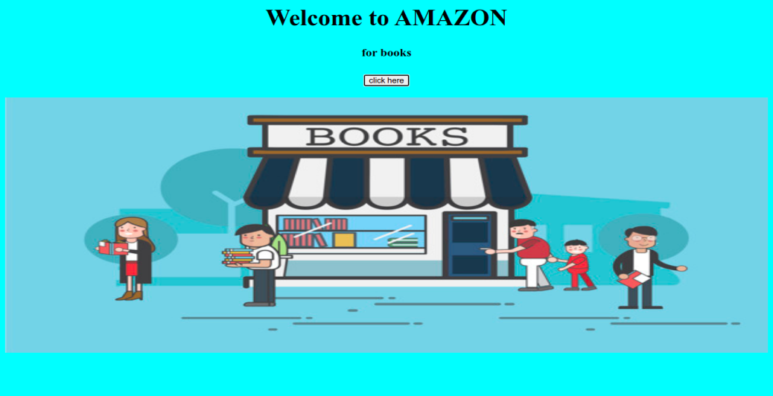

Roll No. : 18WH1A1252 Date:

b)Login Page

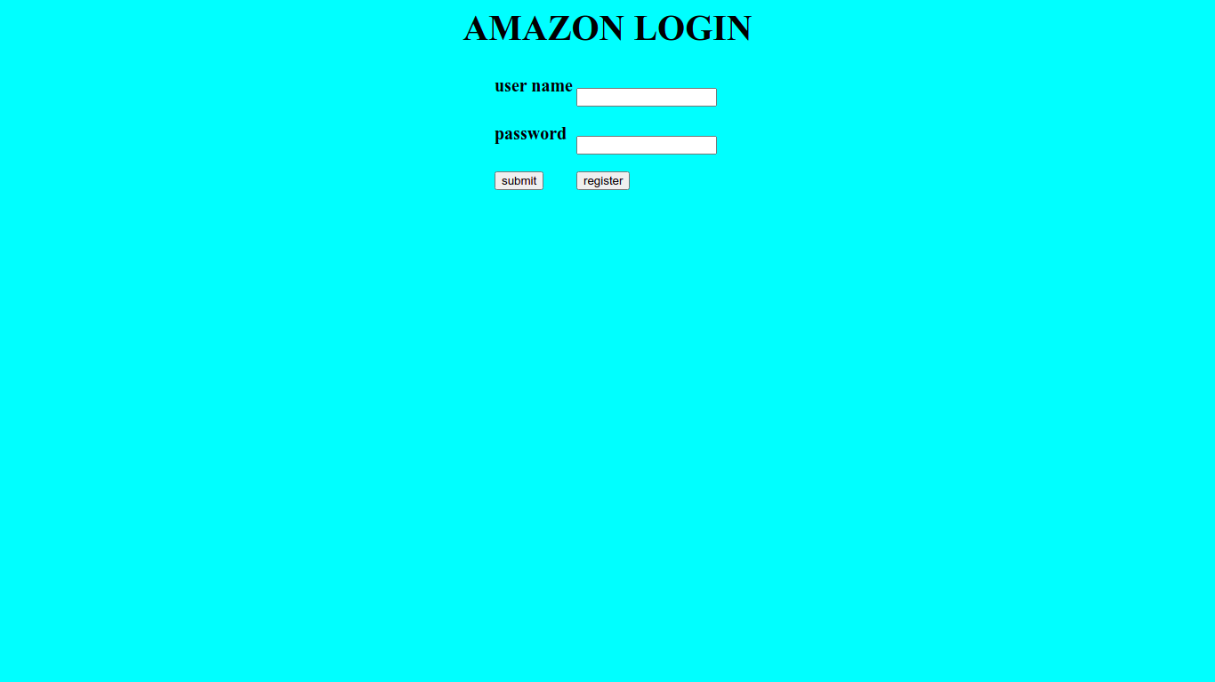

Registration Page

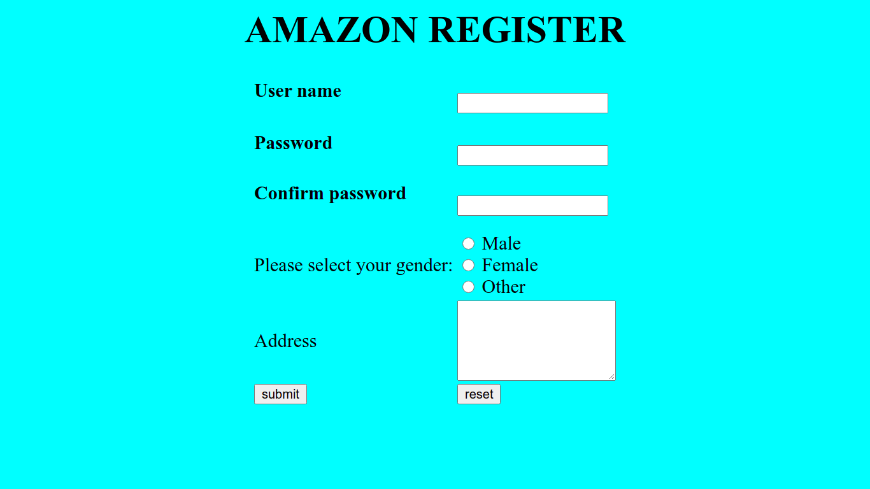

Roll No. : 18WH1A1252 Date:

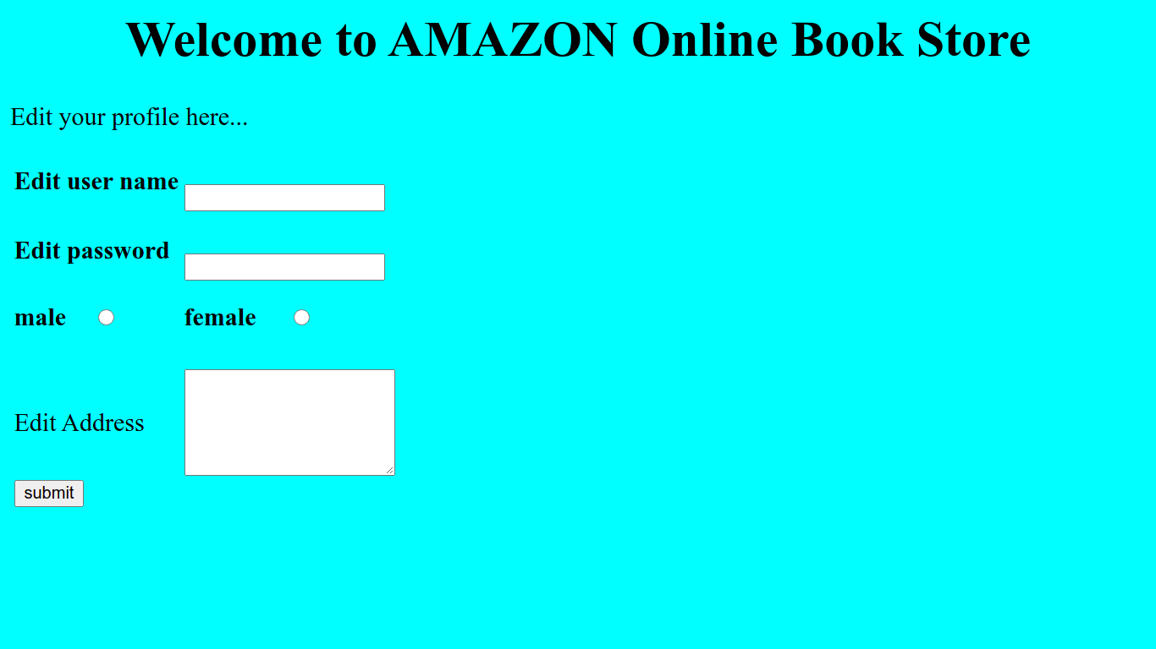c)User Profile page

d)Book Catalog

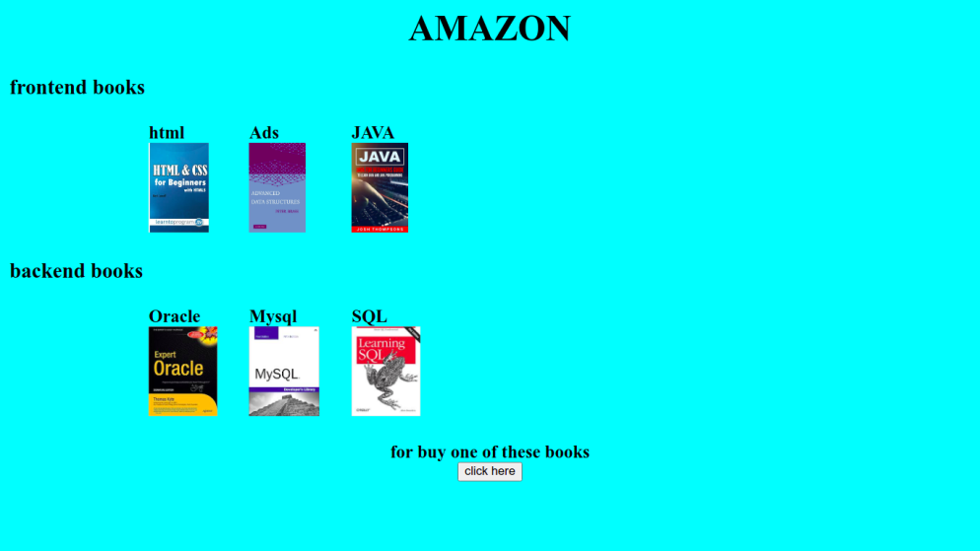

Roll No. : 18WH1A1252 Date:

e) Shopping Page

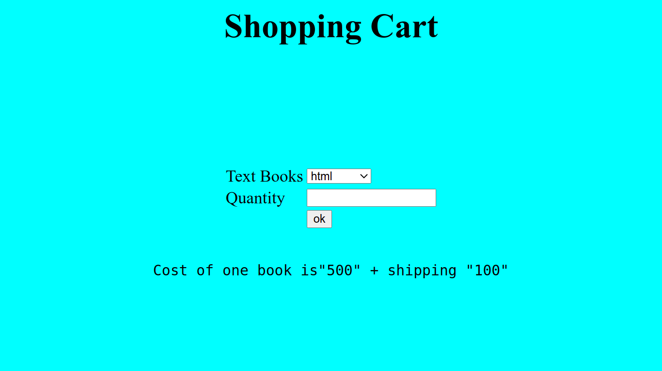

f)Payment Page

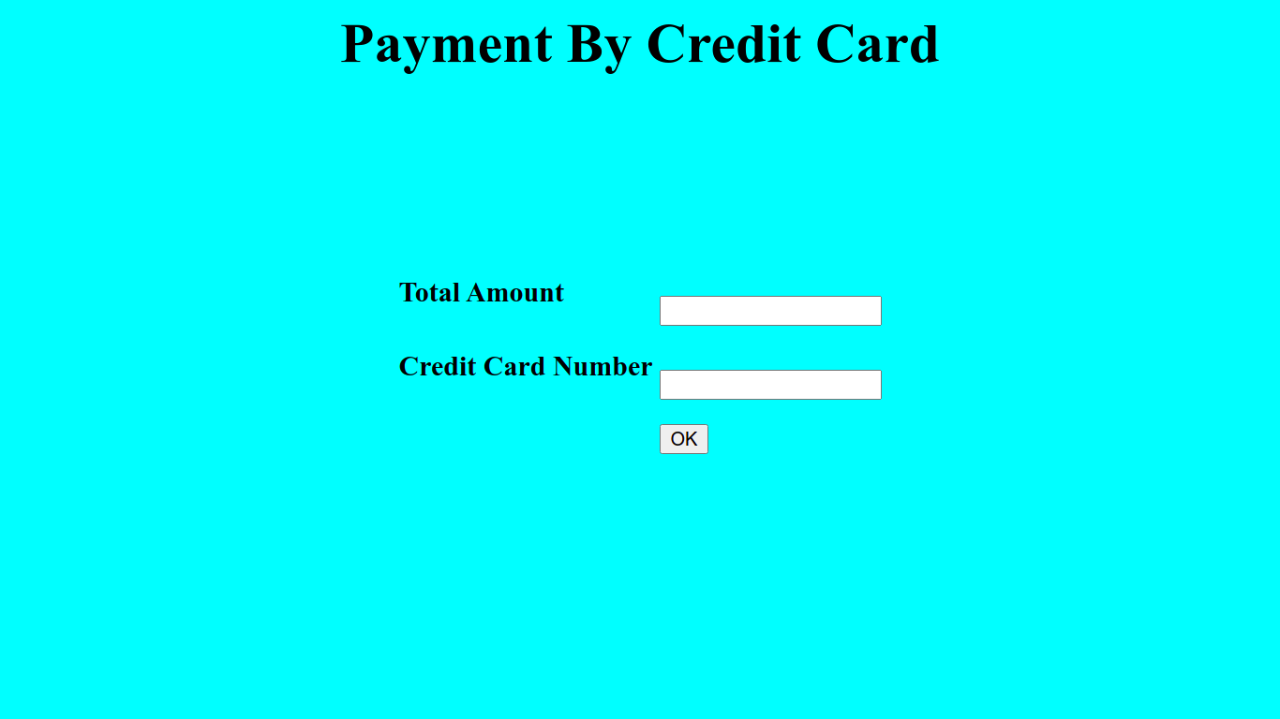

Roll No. : 18WH1A1252 Date:

g)Order Conformation



Roll No. : 18WH1A1252 Date: 16.01.2020

Roll No. : 18WH1A1252 Date: 16.01.2020

Roll No. : 18WH1A1252 Date: 16.01.2020

Roll No. : 18WH1A1252 Date: 16.01.2020